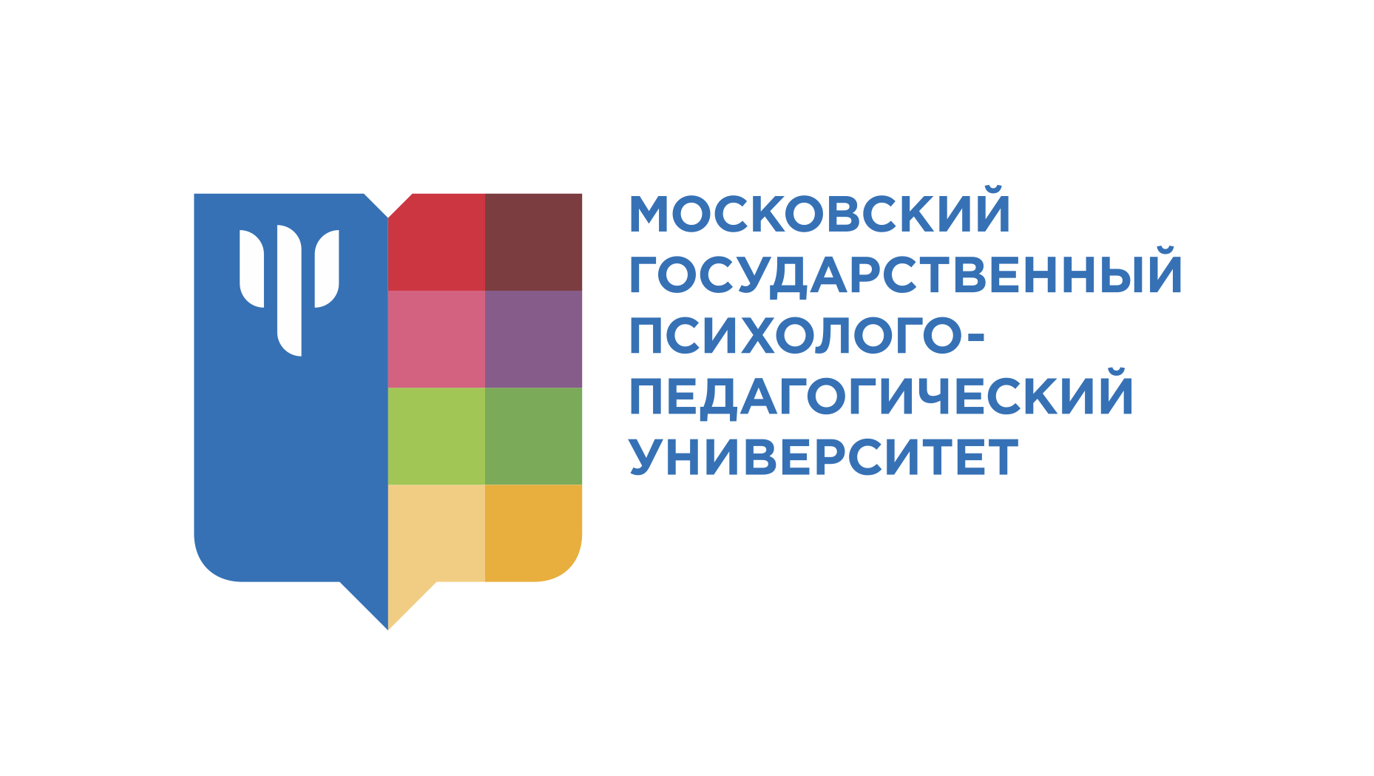

PROGRAM

of the international webinar

Moscow State University for

Psychology and Education

«MEDIATIVE TECHNOLOGIES IN ADDRESSING THE CHILDHOOD SOCIAL RISKS: RUSSIAN AND FINNISH EXPERIENCE»

Format and time – ZOOM, online,

18:00 – 21:00 (Moscow time), 24 November 2021

Working languages: Russian, English (with translation)

18:00 – 18:05 Greetings and opening
Rimma Chirkina, Ph.D., Head of Department for Legal Psychology and Law, Moscow State University for Psychology and Education
Speakers’ presentations
18:05 – 18:40 Restorative Approach in Working with Minors, Their Families and Close Environment
Lyudmila Karnozova, Ph.D., Associate Professor, Department for Legal Psychology and Law, Moscow State University for Psychology and Education; Associate Professor, School of Court Proceedings and Criminal Law, Faculty of Law, National Research University Higher School of Economics; Head of Division 'Restorative Justice Programs in Criminal Matters', Public Center for Legal and Judicial Reform; Member of the European Forum for Restorative Justice
18:40 – 18:45 Q&A
18:45 – 19:20 School Reconciliation Services as a Basis for Realization of Restorative Justice in the Russian Education System
Anton Konovalov, mediator (facilitator), Head of Division 'School Reconciliation Services', Public Center for Legal and Judicial Reform; methodologist of the Moscow Center for Psychology and Education, Moscow Department of Education; Member of the European Forum for Restorative Justice
19:20 – 19:25 Q&A
19:25 – 20:00 Restorative Approach and Mediation in the Finnish Education System
Dr. Maija Gellin, Director of the Programme for Restorative Approach and Mediation in Education ('VERSO-programme'), lecturer at the University of Helsinki and the University of Lapland, member of the Finnish Forum for Mediation, member of the Working Group on Restorative Schools of the European Forum for Restorative Justice, trainer, mediator
20:00 – 20:05 Q&A
20:05 – 20:40 Youth conflicts, Delienquency and Conflict Resolution
Julia Saarholm, Heikki Turkka, Directors of the 'Aseman Lapset' Center
20:40 – 20:25 Q&A and Discussion

Translator – Anna Voronkova

Contact: Olga Kiseleva, Deputy Dean for International Cooperation, Faculty of Legal Psychology, Moscow State University for Psychology and Education (kiselevaop@mgppu.ru)

